**Complie the qmail source on test server**

I use CentOS6 to set up (192.168.114.120)

**PREPARE TO FIX ANY BUGS AT CentOS6:**

sudo sed -i 's/mirrorlist=/#mirrorlist=/g' /etc/yum.repos.d/CentOS-Base.repo

sudo sed -i 's|#baseurl=http://mirror.centos.org|baseurl=http://vault.centos.org|g' /etc/yum.repos.d/CentOS-Base.repo

sudo yum clean all

sudo yum install epel-release -y

setenforce 0

**Install MySQL, HTTPD, PHP**

* Install by yum

yum update -y

yum install httpd -y

yum install mysql-server mysql-devel -y

yum install php php-mysql -y

* restart serice

service httpd start

chkconfig httpd on

service mysqld start

chkconfig mysqld on

**Install WEBMIN**

* Create the /etc/yum.repos.d/webmin.repo:

vi /etc/yum.repos.d/webmin.repo

================================================

[Webmin]

name=Webmin Distribution Neutral

baseurl=http://download.webmin.com/download/yum

mirrorlist=http://download.webmin.com/download/yum/mirrorlist

enabled=1

================================================

* Download and install GPG key :

wget http://www.webmin.com/jcameron-key.asc

rpm --import jcameron-key.asc

* Run “yum install” command to install Webmin software and all required dependencies :

yum install webmin -y

iptables -I INPUT -p tcp --dport 10000

service iptables save

service iptables restart

Test result, browse [https://localhost:10000](http://192.168.56.111:10000/)

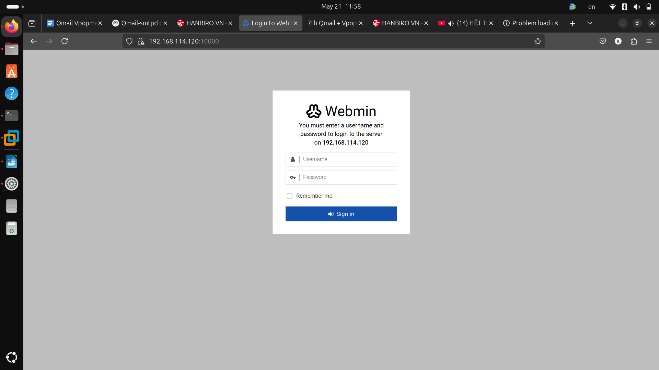

**netqmail-1.06.tar.gz**

Netqmail is a secure, stable, efficient, and simple mail transfer agent (MTA) designed for UNIX systems with Internet access. As of October 2001, qmail is the second most popular SMTP server on the Internet, with growth outpacing other servers.

**ucspi-tcp-0.88.tar.gz**

This package works similarly to inetd, listening on port 25 and launching qmail-smtpd when a connection is made. The abbreviation ucspi stands for "Unix Client Server Program Interface for TCP" - a client-server interface for the TCP protocol on Unix.

**daemontools-0.76.tar.gz**

Daemontools is a set of tools for monitoring and managing background processes (daemons) in Linux. In the qmail system, it is used to control the operation of qmail-related services.

**checkpassword-0.90.tar.gz**

This tool provides a consistent password authentication interface for applications running as root. It is commonly used for services such as login, ftpd, and pop3d.

**qmail-smtpd-auth-0.31.tar.gz**

This is an extension patch that supports the SMTP authentication mechanism (SMTP AUTH) with methods such as: LOGIN, PLAIN, and CRAM-MD5.

* Download all sources into /var/local/src/:

cd /usr/local/src

wget https://qmailrocks.thibs.com/downloads/autorespond-2.0.5.tar.gz

wget https://ftp.netbsd.org/pub/pkgsrc/distfiles/netqmail-1.06.tar.gz

wget https://cr.yp.to/daemontools/daemontools-0.76.tar.gz

wget https://tomclegg.ca/qmail/qmail-smtpd-auth-0.31.tar.gz

wget https://cr.yp.to/checkpwd/checkpassword-0.90.tar.gz

wget https://www.dovecot.org/releases/1.2/dovecot-1.2.6.tar.gz

wget https://cr.yp.to/ucspi-tcp/ucspi-tcp-0.88.tar.gz

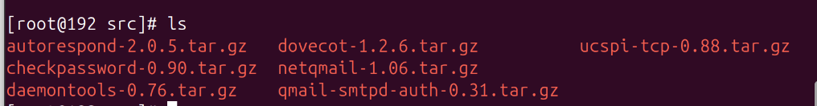

**Install Qmail**

* Create /package directory and move daemontools-0.76.tar.gz to /package.

mkdir /package

mv /usr/local/src/daemontools-0.76.tar.gz /package

**Create users and groups**

* Run following commands to create required users & groups

groupadd nofiles

useradd -g nofiles -d /var/qmail qmaild

useradd -g nofiles -d /var/qmail qmaill

useradd -g nofiles -d /var/qmail qmailp

useradd -g nofiles -d /var/qmail/alias alias

groupadd qmail

useradd -g qmail -d /var/qmail qmailq

useradd -g qmail -d /var/qmail qmailr

useradd -g qmail -d /var/qmail qmails

**Compile & Install**

* Untar the Qmail source

cd /usr/local/src

tar -xzvf netqmail-1.06.tar.gz

* Apply the SMTP patch

cd /usr/local/src

tar -xzvf qmail-smtpd-auth-0.31.tar.gz

cd qmail-smtpd-auth-0.31/

cp README.auth base64.c base64.h ../netqmail-1.06

patch -d ../netqmail-1.06 < auth.patch

* Compile & install qmail.

cd /usr/local/src/netqmail-1.06

make setup check

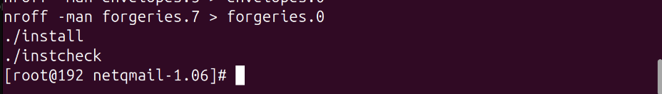

**Configure Qmail**

Post Installation setup

* Post installation configuration can be done by running following script.

./config-fast **mail.kietdemo.local**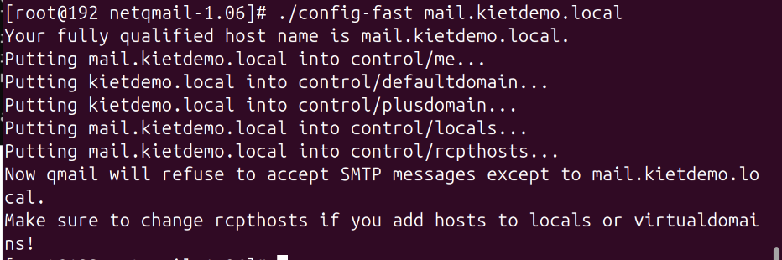

ls /var/qmail/control/*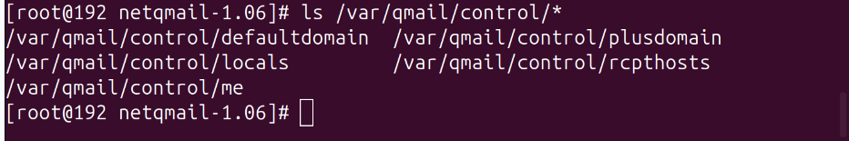

cat /var/qmail/control/defaultdomain (kietdemo.local)

cat /var/qmail/control/plusdomain (kietdemo.local)

cat /var/qmail/control/locals (mail.kietdemo.local)

cat /var/qmail/control/rcpthosts (mail.kietdemo.local)

cat /var/qmail/control/me (mail.kietdemo.local)

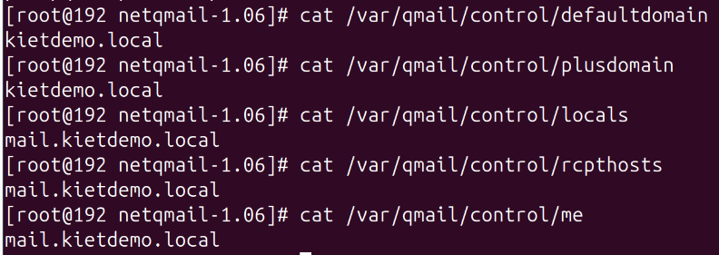

* Create a user named “admin” to receive all administrator emails.

useradd admin

cd ~alias

echo admin > .qmail-postmaster

echo admin > .qmail-mailer-daemon

echo admin > .qmail-root

echo admin > .qmail-abuse

chmod 644 ~alias/.qmail*

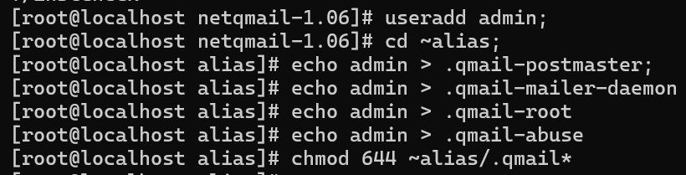

* Create Maildir for “admin” user

su admin -> this command run under admin user

/var/qmail/bin/maildirmake ~/Maildir



**Configure Qmail to use Maildir**

* Create “/var/qmail/rc” with following contents.

exit

vim /var/qmail/rc

==========================================

#!/bin/sh

exec env - PATH="/var/qmail/bin:$PATH" \

qmail-start '|/var/vpopmail/bin/vdelivermail ''./Maildir/'''

==========================================

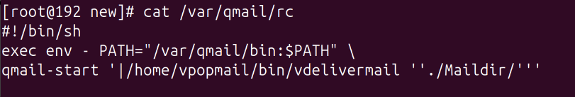

* Create “/var/qmail/control/defaultdelivery” file.

echo ./Maildir/ >/var/qmail/control/defaultdelivery

* Make “/var/qmail/rc” executable

chmod 755 /var/qmail/rc

* Create “/var/qmail/control/defaultdelivery” file.

echo ./Maildir/ >/var/qmail/control/defaultdelivery

* Replace Sendmail binaries

chmod 0 /usr/lib/sendmail

chmod 0 /usr/sbin/sendmail

mv /usr/lib/sendmail /usr/lib/sendmail.bak

mv /usr/sbin/sendmail /usr/sbin/sendmail.bak

ln -s /var/qmail/bin/sendmail /usr/lib/sendmail

ln -s /var/qmail/bin/sendmail /usr/sbin/sendmail

* Replace Sendmail binaries

chmod 0 /usr/lib/sendmail ;

chmod 0 /usr/sbin/sendmail ;

mv /usr/lib/sendmail /usr/lib/sendmail.bak ;

mv /usr/sbin/sendmail /usr/sbin/sendmail.bak ;

ln -s /var/qmail/bin/sendmail /usr/lib/sendmail ;

ln -s /var/qmail/bin/sendmail /usr/sbin/sendmail ;

*=> Replace sendmail binaries because some program still use sendmail for default*

**Install ucspi-tcp**

* Untar the ucspi-tcp source.

cd /usr/local/src/

tar -xzvf ucspi-tcp-0.88.tar.gz

* Patch ucspi-tcp with “ucspi-tcp-0.88.errno.patch” provided with net qmail.

cd ucspi-tcp-0.88

patch < /usr/local/src/netqmail-1.06/other-patches/ucspi-tcp-0.88.errno.patch

* Install ucspi-tcp.

make

make setup check

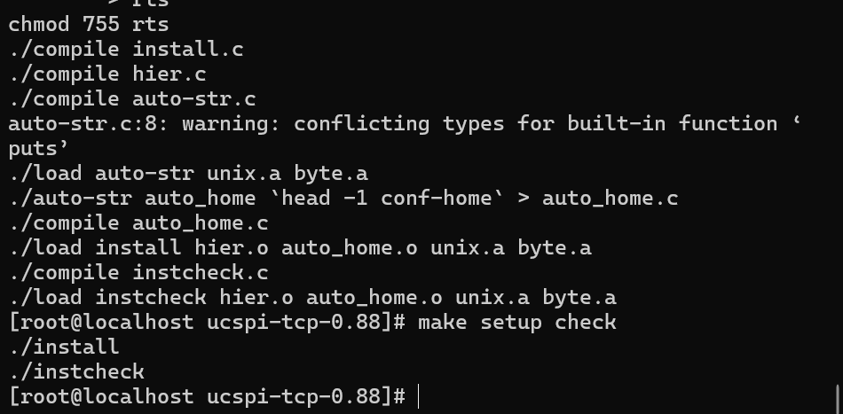

**Install checkpassword**

* Untar checkpassword source.

cd /usr/local/src

tar -xzvf checkpassword-0.90.tar.gz

* Patch checkpassword with “checkpassword-0.90.errno.patch” provided with net qmail.

cd checkpassword-0.90

patch < /usr/local/src/netqmail-1.06/other-patches/checkpassword-0.90.errno.patch

* Install checkpassword.

make setup check

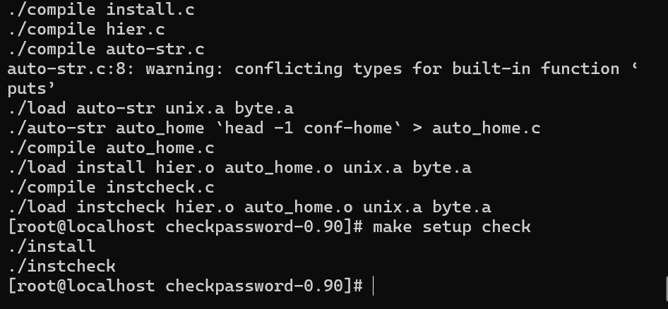

**Install daemontools**

* Untar the daemontools source

cd /package

tar -xzvf daemontools-0.76.tar.gz

* Patch daemontools with “daemontools-0.76.errno.patch” provided with net qmail.

cd /package/admin/daemontools-0.76/src

patch < /usr/local/src/netqmail-1.06/other-patches/daemontools-0.76.errno.patch

* Install daemontools

cd ..

./package/install

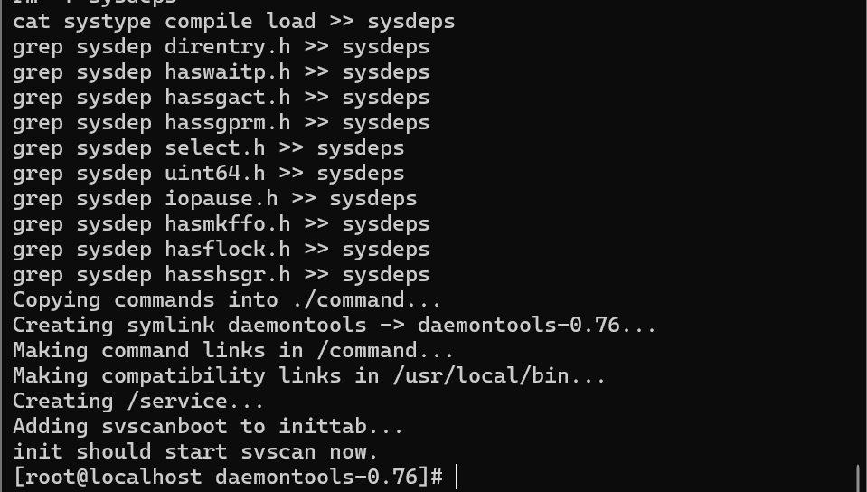

* Qmail Startup script

cd /var/qmail/bin

wget http://lifewithqmail.org/qmailctl-script-dt70

* Setup qmailctl

mv qmailctl-script-dt70 qmailctl

chmod 755 /var/qmail/bin/qmailctl

ln -s /var/qmail/bin/qmailctl /usr/bin

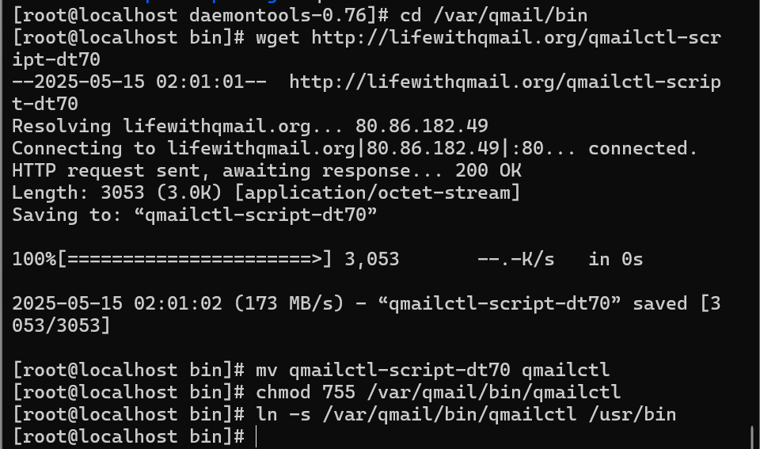

* Setup qmail-send & qmail-smtpd

mkdir -p /var/qmail/supervise/qmail-send/log

mkdir -p /var/qmail/supervise/qmail-smtpd/log

mkdir -p /var/qmail/supervise/qmail-pop3d/log

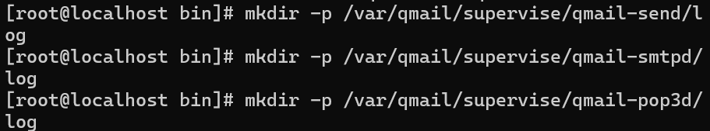

* Create supervise script for qmail-send

vim /var/qmail/supervise/qmail-send/run

================

#!/bin/sh

exec /var/qmail/rc

================

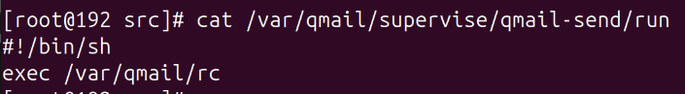

* Create qmail-send log daemon supervise script

mkdir -p /var/log/qmail

vim /var/qmail/supervise/qmail-send/log/run

======================================================

#!/bin/sh

exec /usr/local/bin/setuidgid qmaill /usr/local/bin/multilog t /var/log/qmail

======================================================



* qmail-smtpd daemon supervise script

vim /var/qmail/supervise/qmail-smtpd/run

===============================================================

#!/bin/sh

set -x

QMAILDUID=`id -u qmaild`

NOFILESGID=`id -g qmaild`

MAXSMTPD=`cat /var/qmail/control/concurrencyincoming`

LOCAL=`head -1 /var/qmail/control/me`

if [ -z "$QMAILDUID" -o -z "$NOFILESGID" -o -z "$MAXSMTPD" -o -z "$LOCAL" ]; then

echo QMAILDUID, NOFILESGID, MAXSMTPD, or LOCAL is unset in

echo /var/qmail/supervise/qmail-smtpd/run

exit 1

fi

if [ ! -f /var/qmail/control/rcpthosts ]; then

echo "No /var/qmail/control/rcpthosts!"

echo "Refusing to start SMTP listener because it’ll create an open relay"

exit 1

fi

exec /usr/local/bin/softlimit -m 9000000 /usr/local/bin/tcpserver -v -R -l "$LOCAL" -x /etc/tcp.smtp.cdb -c "$MAXSMTPD" -u "$QMAILDUID" -g "$NOFILESGID" 0 smtp /var/qmail/bin/qmail-smtpd 2>&1

===============================================================

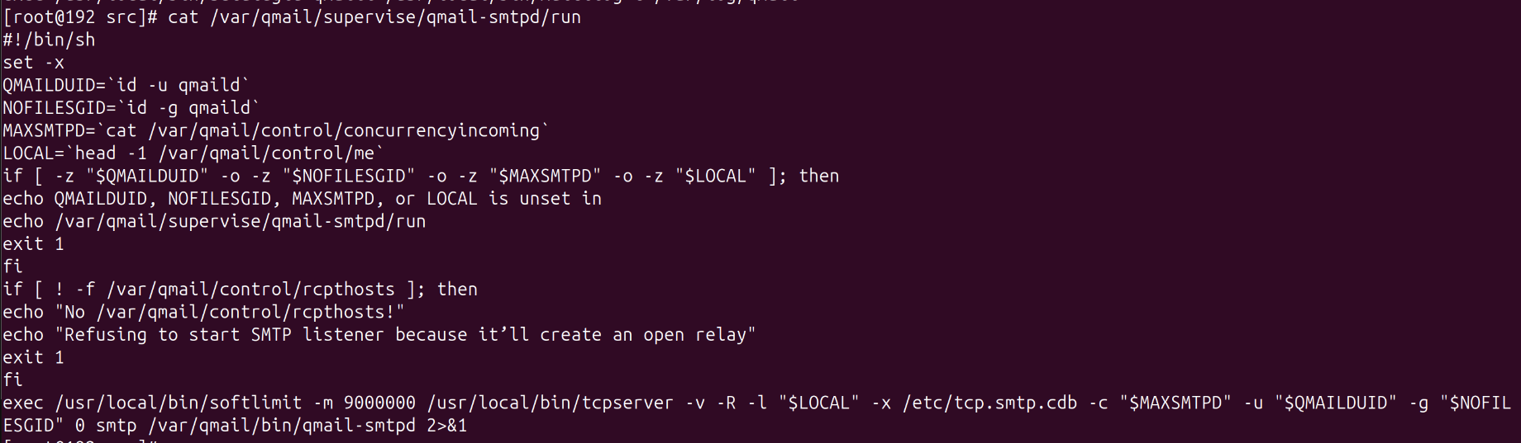

* Create the concurrencyincoming control file.

echo 20 > /var/qmail/control/concurrencyincoming

chmod 644 /var/qmail/control/concurrencyincoming

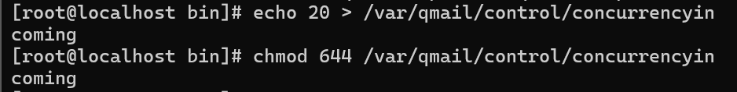

* config allow address:

vim /etc/tcp.smtp

======================

127.:allow,RELAYCLIENT=""

======================

* compile file:

tcprules /etc/tcp.smtp.cdb /etc/tcp.smtp.tmp < /etc/tcp.smtp



* qmail-smtpd log daemon supervise script

vim /var/qmail/supervise/qmail-smtpd/log/run

===========================================================

#!/bin/sh

exec /usr/local/bin/setuidgid qmaill /usr/local/bin/multilog t /var/log/qmail/smtpd

===========================================================



* Create the log directories and add execute permissions on the run scripts:

mkdir -p /var/log/qmail/smtpd

chown qmaill /var/log/qmail

chown qmaill /var/log/qmail/smtpd

chmod 755 /var/qmail/supervise/qmail-send/run

chmod 755 /var/qmail/supervise/qmail-send/log/run

chmod 755 /var/qmail/supervise/qmail-smtpd/run

chmod 755 /var/qmail/supervise/qmail-smtpd/log/run

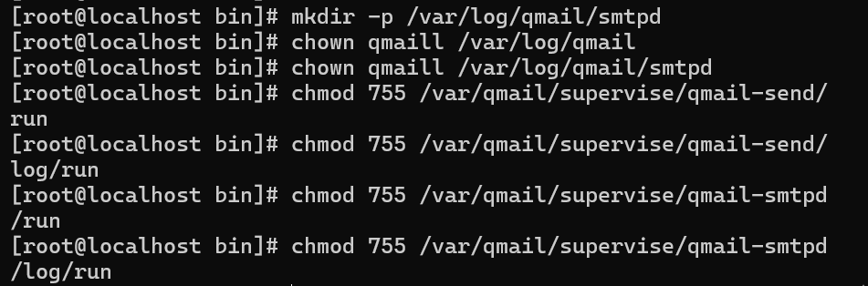

**Create soft link for the daemons in /service folder:**

* Add qmail-send to /service folder:

ln -s /var/qmail/supervise/qmail-send /service/qmail-send

* Add qmail-smtpd to /service folder:

ln -s /var/qmail/supervise/qmail-smtpd /service/qmail-smtpd

Note:

* The /service directory is created when daemontools is installed
* The qmail system will start automatically shortly after these links are created

** Before running command qmailctl, You should run “daemontools” with following command

/command/svscanboot &

**[ OR ]**

Start daemontools with Upstart on CentOS 6.5 as it doesn’t work with sysvinit:

Command the line from nano /etc/inittab :

==================================

#SV:123456:respawn:/command/svscanboot

==================================

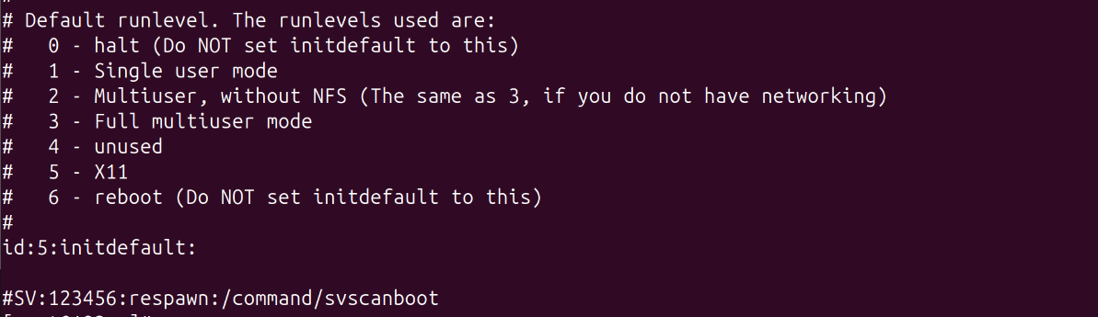

* Create a new file /etc/init/svscan.conf , with the startup code in it:

vim /etc/init/svscan.conf

=====================

start on runlevel [345]

respawn

exec /command/svscanboot

=====================

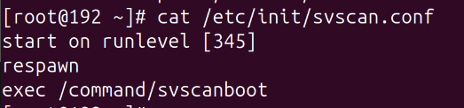

* Tell init to re-read its configuration files and start svscanboot:

initctl reload-configuration

initctl start svscan

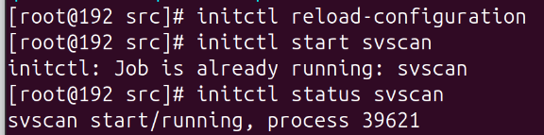

**Install autorespond**

cd /usr/local/src/

tar zxvf autorespond-2.0.5.tar.gz

cd autorespond-2.0.5

gcc -Wall -o autorespond autorespond.c

cp autorespond /usr/local/bin/

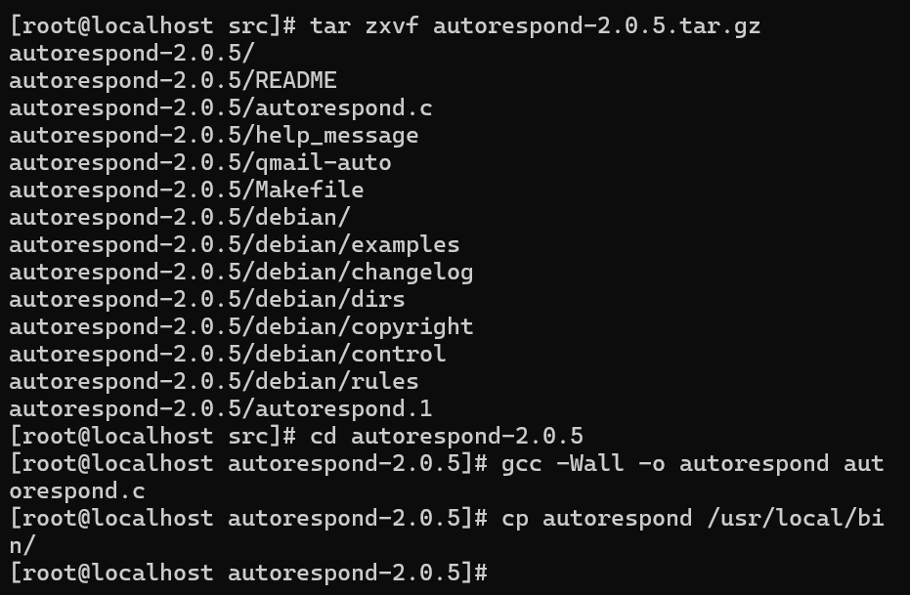

**research about tcp.smtp** (SMTP Access Control for Qmail)

The /etc/tcp.smtp file controls which hosts or networks are allowed to connect and send emails through your Qmail server. It works in conjunction with tcpserver

Main functions:

* Access control: Allow or deny connections to the SMTP port (port 25) based on the source IP address
* Open Relay Prevention: Proper configuration helps prevent the server from being exploited to send spam
* Special rules: Allow different behaviors based on the source IP (allow relays from the internal network, …)

Rule syntax (one rule per line):

**ip_address_or_network:action[,variable=value,...]**

* ip_address_or_network: specific IP (192.168.114.120), CIDR range (192.168.114.0/24), partial IP (192.168.114.), or : (all IPs)
* action: allow or deny
* variable=value (optional): Sets environment variables. Most important for relaying is RELAYCLIENT="" (allow relay from this address/network)

Processing order: tcpserver reads and applies the first rule that matches the connecting IP address, from top to bottom

Using with tcprules:

* The tcp.smtp file needs to be converted to CDB format (/etc/tcp.smtp.cdb) using the tcprules command so that tcpserver can read it effectively
* After modifying tcp.smtp, it is necessary to rerun tcprules to update tcp.smtp.cdb

Example configuration:

127.0.0.1:allow,RELAYCLIENT="" # Allow relay from localhost

192.168.114.:allow,RELAYCLIENT="" # Allow relay from network 192.168.114.x

trusted.ip:allow,RELAYCLIENT="" # Allow relay from trusted IP (ex: 192.168.114.120)

:deny # Deny all other connections

**Research and setting SPF, DKIM**

**SPF (Sender Policy Framework)** is essentially a security protocol designed to prevent malicious people from sending emails on your behalf. It works through communication between DNS servers

**DKIM (DomainKeys Identified Mail)** - the DKIM standard was developed with the same purpose as SPF: to prevent others from impersonating you as the sender of an email. This is a way to enhance security by digitally signing emails, helping the receiving mail server verify the true origin of the sender

**SPF and DKIM settings**

=> prepare DNS:

* Install bind:

yum install bind bind-utils -y

vi /etc/named/kietdemo.local.db

===========================================

$TTL 86400

@ IN SOA ns1.kietdemo.local. admin.kietdemo.local. (

2025051901 ; Serial

3600 ; Refresh

1800 ; Retry

1209600 ; Expire

86400 ) ; Minimum TTL

; Name Servers

@ IN NS ns1.kietdemo.local.

; Mail Exchanger

@ IN MX 10 mail.kietdemo.local.

; A Record for mail server

@ IN A 192.168.114.120

ns1 IN A 192.168.114.120

mail IN A 192.168.114.120

===========================================

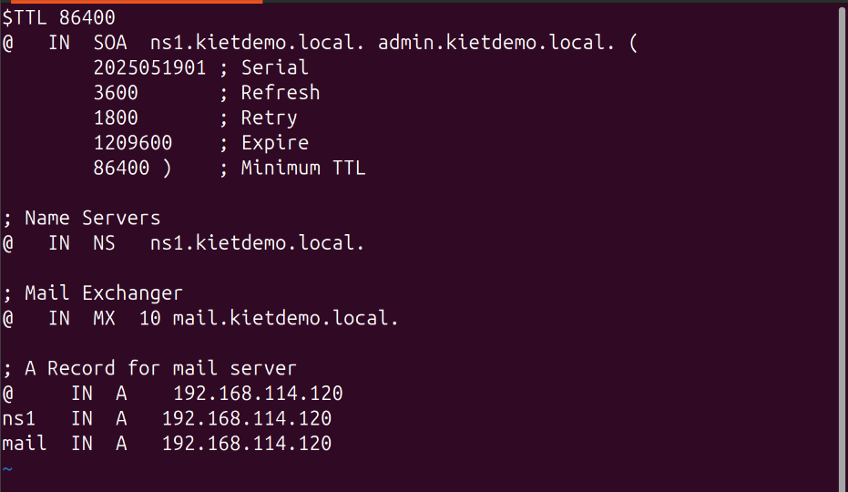

vi /etc/named.conf

=====================================

listen-on port 53 { 127.0.0.1; 192.168.114.120; };

allow-query { any; };

recursion yes;

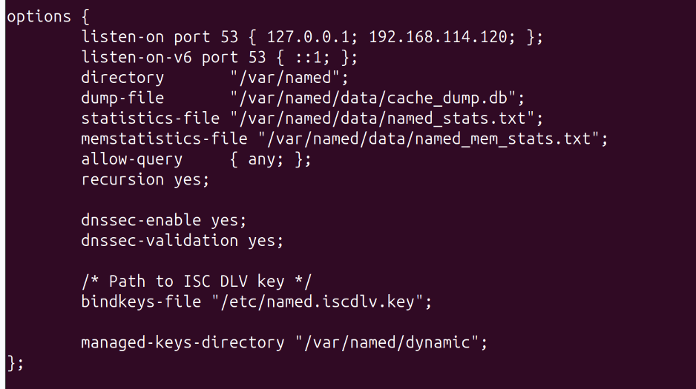

zone "kietdemo.local" IN {

type master;

file "/etc/named/kietdemo.local.db";

};

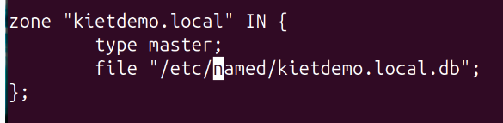

=====================================

* Config firewall:

iptables -A INPUT -p udp --dport 53 -j ACCEPT

iptables -A INPUT -p tcp --dport 53 -j ACCEPT

service iptables save

service iptables restart

* Restart service:

service named restart

* Check DNS:

dig @localhost kietdemo.local

;; ANSWER SECTION:

kietdemo.local. 86400 IN A 192.168.114.120

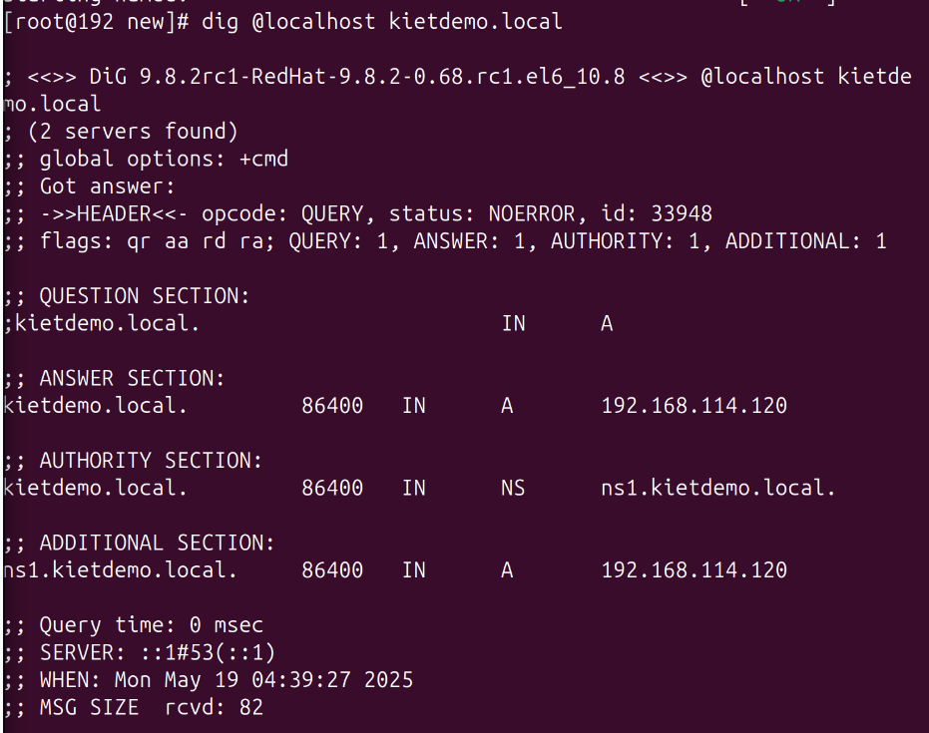

* Check MX record:

dig @192.168.114.120 MX kietdemo.local

;; ANSWER SECTION:

kietdemo.local. 86400 IN MX 10 mail.kietdemo.local.

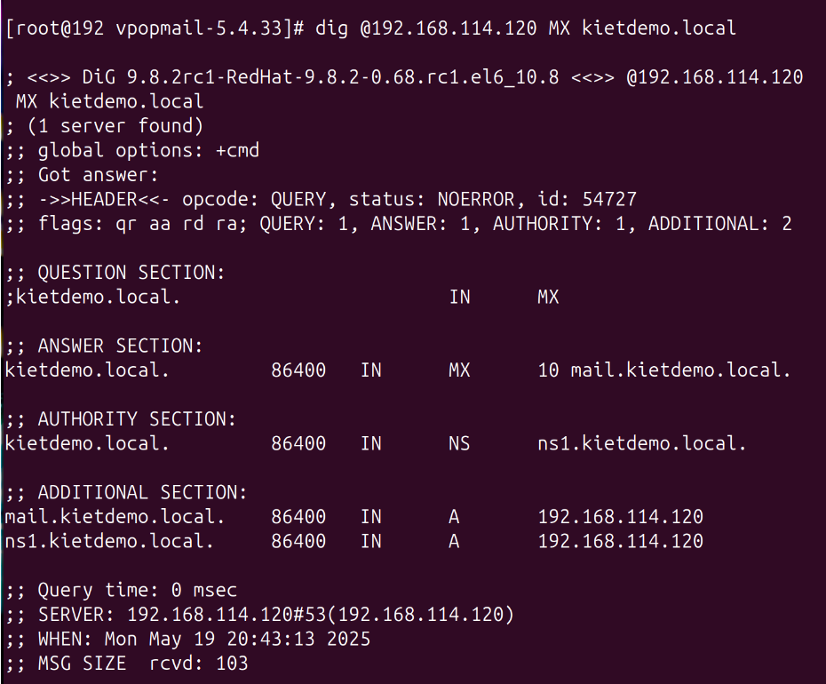

**SPF Setup**

* Insert the following line into the DNS server's zone file:

vi /etc/named/kietdemo.local.db

============================

@ IN TXT "v=spf1 a mx -all"

============================

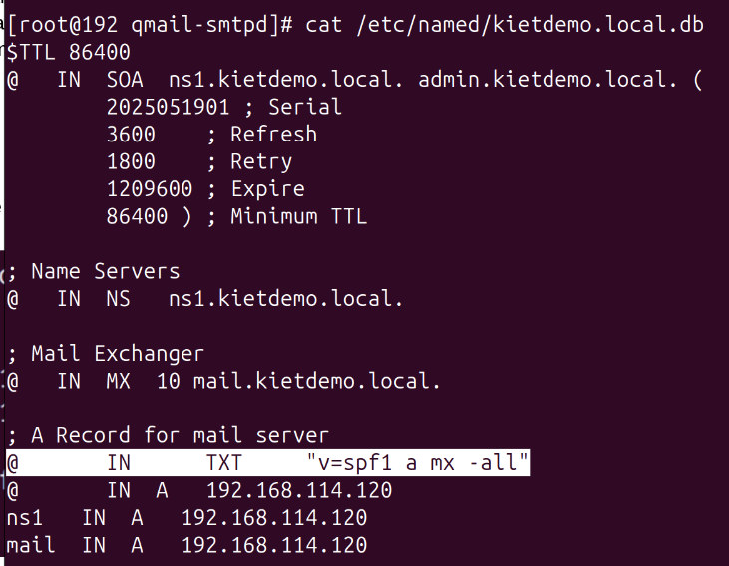

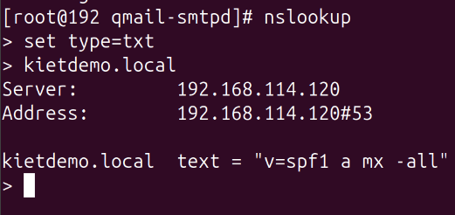

**DKIM setup**

yum install opendkim -y

opendkim-genkey -s mail -d kietdemo.local -t

cat mail.txt

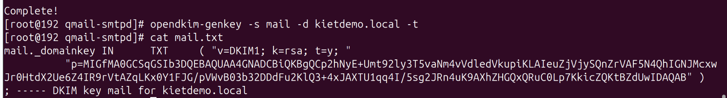

nano /etc/named/kietdemo.local.db (add content of mail.txt)

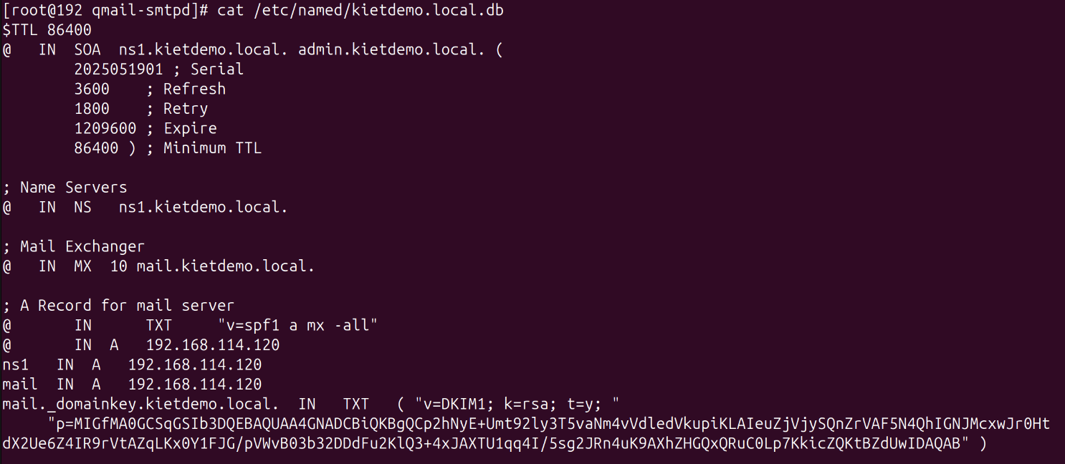

* check syntax:

named-checkzone kietdemo.local /etc/named/kietdemo.local.db

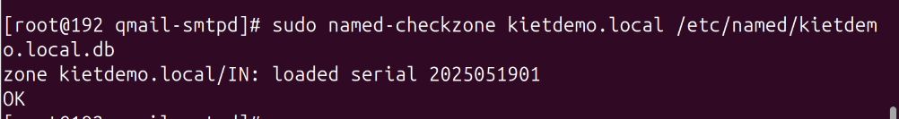

* restart service:

service named restart

* check:

nslookup

> set type=txt

> mail._domainkey.kietdemo.local

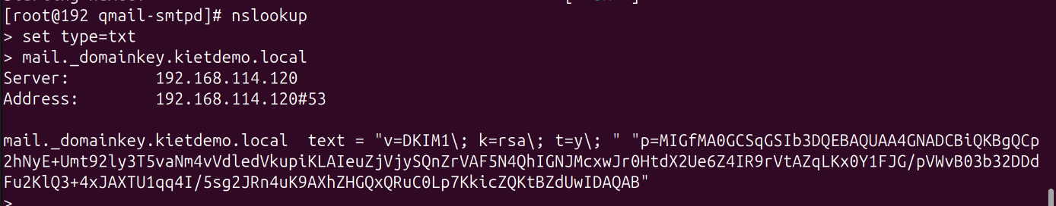

**Explain all functions in /var/qmail/control**: this is the directory that contains important Qmail configuration files. Here are some common ones explained:

* **badmailfrom**: Contains a list of email addresses or address patterns that are prohibited from sending mail via your Qmail server.
* **bouncehost**: Specifies the hostname used in bounce messages.
* **concurrencylocal**: Specifies the maximum number of qmail-local processes that can run concurrently to handle sending mail to local addresses.
* **concurrencynum**: Specifies the maximum number of qmail-send processes that can be run concurrancy.
* **controlcf**: This directory contains other configuration files that are less directly modified.
* **defaultdomain**: The default domain added to local email addresses that do not have a domain.
* **locals**: Lists the local domains that this Qmail server accepts incoming mail for.
* **me**: The hostname of the Qmail system.
* **plusdomain**: The domain used for plus addressing or subaddressing.
* **qmail-send.pid**: The file containing the process ID (PID) of the running qmail-send process.
* **queuelifetime**: The maximum time (in seconds) that a message will be held in the queue before being returned.
* **rcpthosts**: Lists the domains or IP addresses that this Qmail server is allowed to relay mail to. This is an important security file.
* **smtproutes**: Defines special routes for sending mail to specific domains.
* **virtualdomains**: Lists the virtual domains that the Qmail server serves, allowing you to have multiple email domains on the same server.

**Compile VPOPMAIL**

* create build directory:

mkdir -p /usr/local/src/build

cd /usr/local/src/build

* download source, extract file and configure:

wget --no-check-certificate 'https://drive.google.com/uc?export=download&id=1fWvx_838UXn9NVEfx7loO4ZXhvwWqO2e' -O vpopmail-5.4.33.tar.gz

tar xvzf vpopmail-5.4.33.tar.gz

cd vpopmail-5.4.33

groupadd vchkpw

mkdir /var/vpopmail

useradd -g vchkpw -d /var/vpopmail vpopmail

./configure \

--enable-qmaildir=/var/qmail/ \

--enable-qmail-newu=/var/qmail/bin/qmail-newu \

--enable-qmail-inject=/var/qmail/bin/qmail-inject \

--enable-qmail-newmrh=/var/qmail/bin/qmail-newmrh \

--disable-roaming-users \

--enable-auth-module=mysql \

--enable-incdir=/usr/include/mysql \

--enable-libdir=/usr/lib64/mysql \

--enable-logging=p \

--disable-clear-passwd \

--enable-auth-logging \

--enable-sql-logging \

--disable-valias \

--disable-passwd \

--enable-qmail-ext \

--enable-learn-passwords \

--enable-mysql-limits \

--enable-sql-aliasdomains \

--enable-defaultdelivery

Note:

| **Option** | **Description** |
| --- | --- |
| --enable-qmaildir=/var/qmail/ | Set the root directory of Qmail |
| --enable-qmail-newu=/var/qmail/bin/qmail-newu | Configure the path of qmail-newu to manage new users |
| --enable-qmail-inject=/var/qmail/bin/qmail-inject | Set the path for qmail-inject (send emails to the system) |
| --enable-qmail-newmrh=/var/qmail/bin/qmail-newmrh | Set the path for qmail-newmrh (manage new emails) |
| --disable-roaming-users | Disable the feature of allowing mobile users |
| --enable-auth-module=mysql | Use MySQL as the authentication system |
| --enable-incdir=/usr/include/mysql | Set the directory containing the MySQL header files |
| --enable-libdir=/usr/lib64/mysql | Set the directory containing the MySQL library |
| --enable-logging=p | Enable logging |
| --disable-clear-passwd | Disable clear password usage |
| --enable-auth-logging | Log authentication events |
| --enable-sql-logging | Log SQL queries |
| --disable-valias | Disable email alias |
| --disable-passwd | Disable password usage |
| --enable-qmail-ext | Enable Qmail extensions |
| --enable-learn-passwords | Allow Qmail to learn user passwords |
| --enable-mysql-limits | Enable MySQL limits (such as the number of emails sent) |
| --enable-sql-aliasdomains | Support alias domains in SQL |
| --enable-defaultdelivery | Enable default delivery mode |

* had more information [ current setting vpopmail 5.4.33 ]

**vpopmail 5.4.33**

**Current settings**

---------------------------------------

vpopmail directory = /home/vpopmail

domains directory = /home/vpopmail/domains

uid = 509

gid = 509

roaming users = ON --enable-roaming-users

tcpserver file = /etc/tcp.smtp

open_smtp file = /home/vpopmail/etc/open-smtp

rebuild tcpserver file = ON --enable-rebuild-tcpserver-file (default)

password learning = OFF --disable-learn-passwords (default)

md5 passwords = ON --enable-md5-passwords (default)

file locking = ON --enable-file-locking (default)

vdelivermail fsync = OFF --disable-file-sync (default)

make seekable = ON --enable-make-seekable (default)

clear passwd = ON --enable-clear-passwd (default)

user dir hashing = ON --enable-users-big-dir (default)

address extensions = OFF --disable-qmail-ext (default)

ip alias = ON --enable-ip-alias-domains

onchange script = OFF --disable-onchange-script (default)

domain quotas = OFF --disable-domainquotas (default)

auth module = cdb --enable-auth-module=cdb (default)

auth inc = -Icdb

auth lib =

system passwords = OFF --disable-passwd (default)

pop syslog = show successful and failed login attempts --enable-logging=y

auth logging = ON --enable-auth-logging (default)

spamassassin = OFF --disable-spamassassin (default)

maildrop = OFF --disable-maildrop (default)

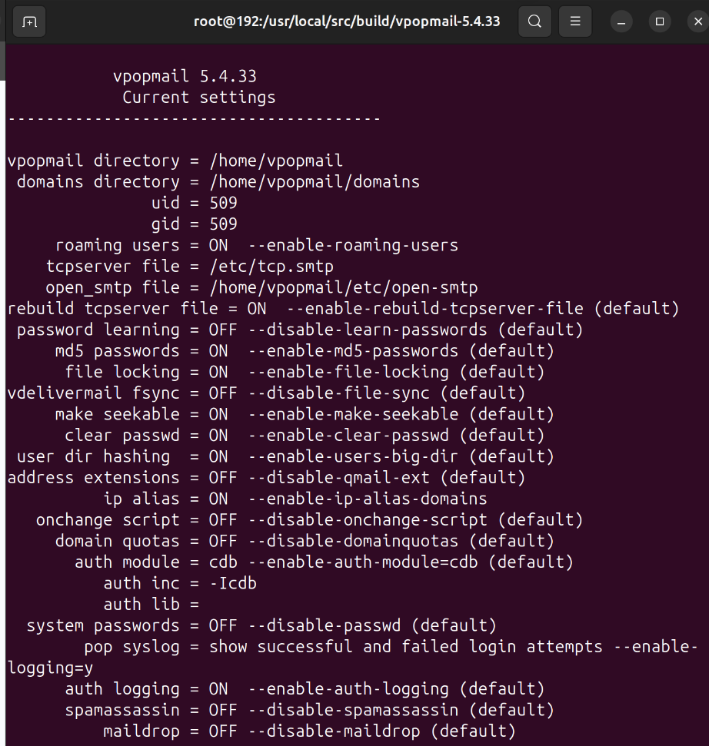

make

make install-strip

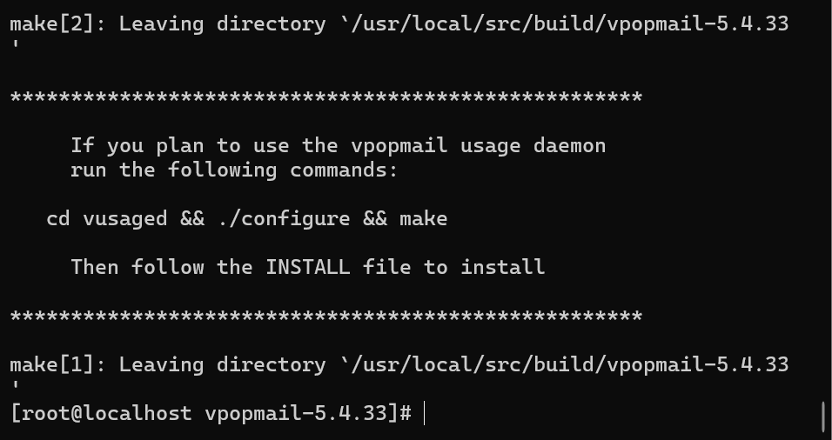

**Install Dovecot**

**Dovecot** is an open source IMAP and POP3 email server for Linux/UNIX-like systems, written with security primarily in mind. Dovecot is an excellent choice for both small and large installations. It’s fast, simple to set up, requires no special administration and it uses very little memory.

* download source & tools + configure:

cd /usr/local/src

tar -xzvf dovecot-1.2.6.tar.gz

cd dovecot-1.2.6

yum install pam-devel openssl-devel -y

./configure \

--with-ioloop=epoll \

--with-notify=inotify \

--with-ssl=openssl \

--with-passwd \

--with-shadow \

--with-pam \

--with-checkpassword \

--with-vpopmail \

--with-static-userdb

Note:

| **Option** | **Description** |
| --- | --- |
| --with-ioloop=epoll | Use epoll for I/O event loop (efficient on Linux). |
| --with-notify=inotify | Use inotify to notify file system changes. |
| --with-ssl=openssl | Enable SSL using openssl for secure connections. |
| --with-passwd | Enable password support for users. |
| --with-shadow | Enable support for shadow (password security for Unix users). |
| --with-pam | Enable support for PAM (Pluggable Authentication Modules). |
| --with-checkpassword | Enable external password checking program. |
| --with-vpopmail | Enable integration with vpopmail for email management with Qmail. |
| --with-static-userdb | Use a static user database instead of dynamic user database. |

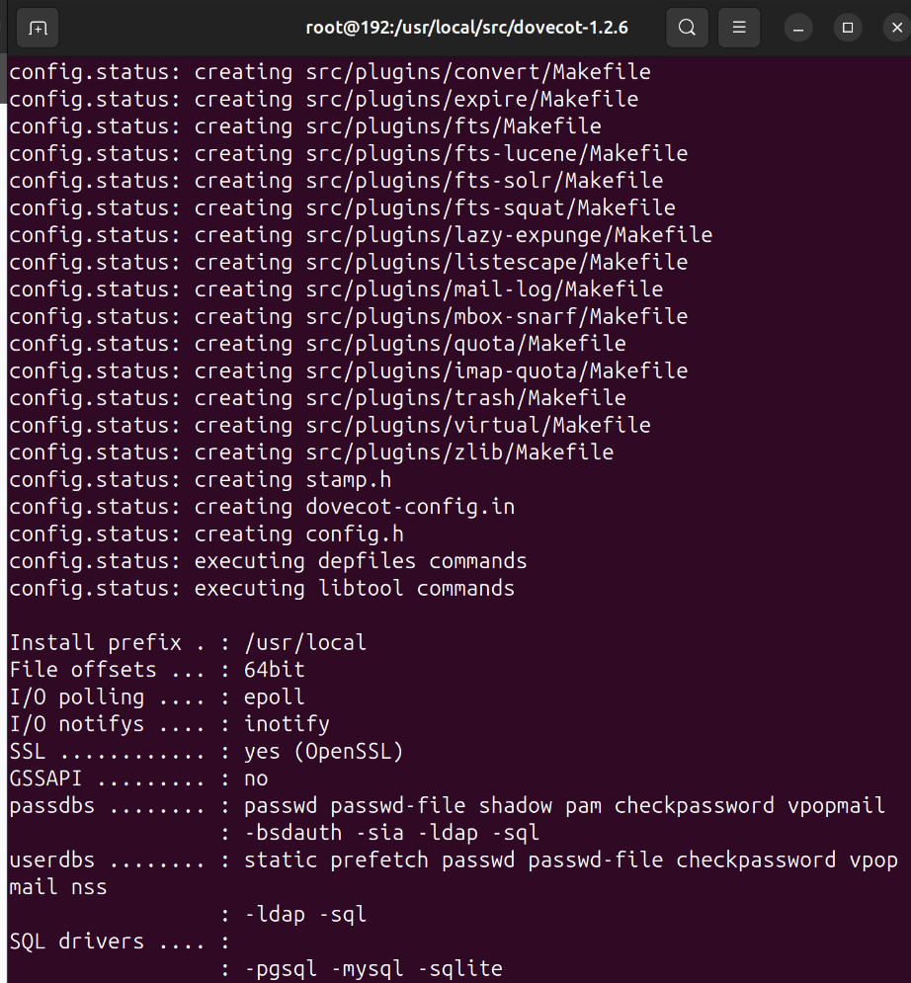

make

make install

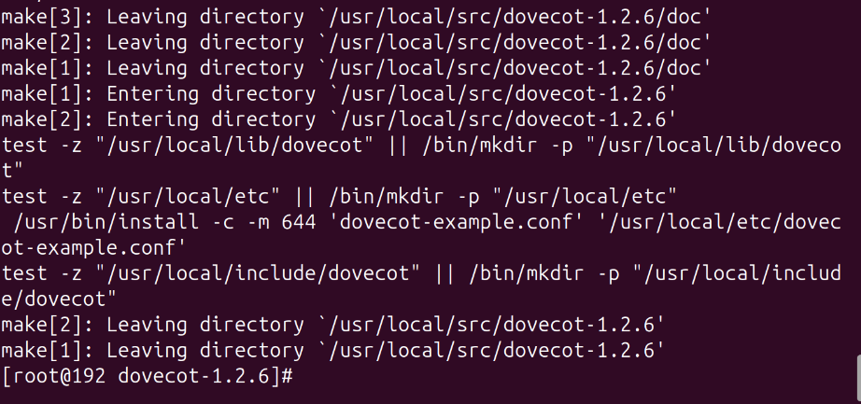

* Create certificate:

mkdir -p /etc/ssl/certs/

mkdir -p /etc/ssl/private/

cd /usr/local/src/dovecot-1.2.6/doc/

chmod 755 mkcert.sh

./mkcert.sh

* This will create /etc/ssl/certs/dovecot.pem & /etc/ssl/private/dovecot.pem:

Generating a 1024 bit RSA private key

...................................................++++++

.....................++++++

writing new private key to '/etc/ssl/private/dovecot.pem'

-----

subject= /OU=IMAP server/CN=imap.example.com/emailAddress=postmaster@example.com

SHA1 Fingerprint=5C:B3:70:20:2D:3D:C0:33:44:42:2A:79:D1:8B:FA:38:CF:87:77:D3

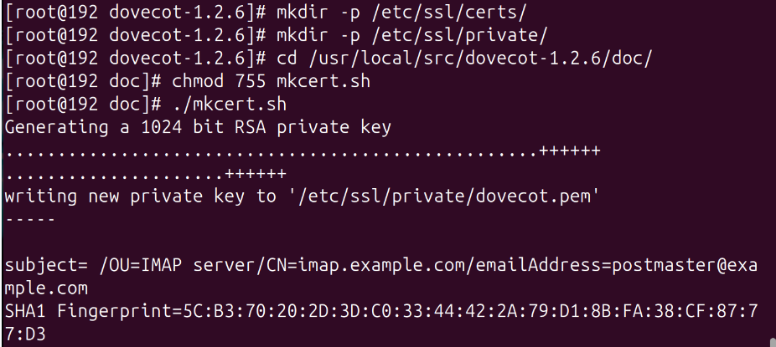

* Create /etc/pam.d/dovecot
* Contents of vim /etc/pam.d/dovecot is given below:

=========================

auth required pam_unix.so nullok

account required pam_unix.so

=========================

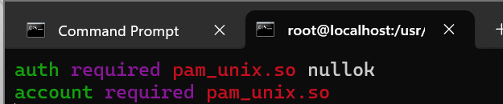

* Create dovecot.conf file

cp -pv /usr/local/etc/dovecot-example.conf /usr/local/etc/dovecot.conf

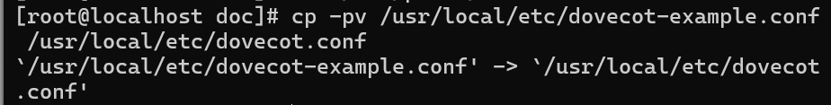

* Modify nano /usr/local/etc/dovecot.conf as given below:

================================================

protocols = imap imaps pop3 pop3s

disable_plaintext_auth = no

ssl_cert_file = /etc/ssl/certs/dovecot.pem

ssl_key_file = /etc/ssl/private/dovecot.pem

first_valid_uid = 89

first_valid_gid = 1

passdb vpopmail {

args = webmail=127.0.0.1

}

userdb vpopmail {

args = quota_template=quota_rule=*:backend=%q

}

mail_location = maildir:/var/vpopmail/domains/%d/%n/Maildir

================================================

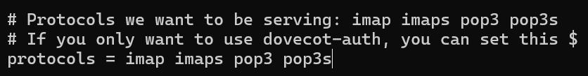

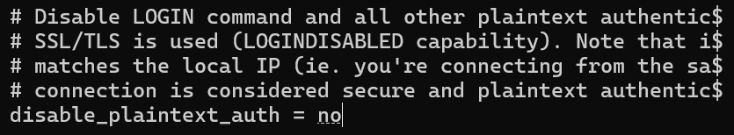

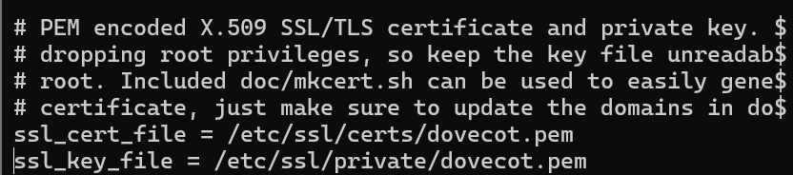

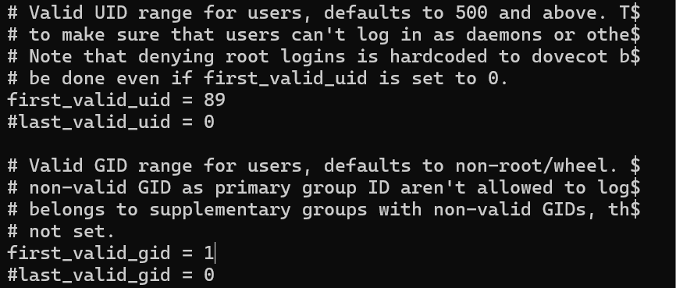

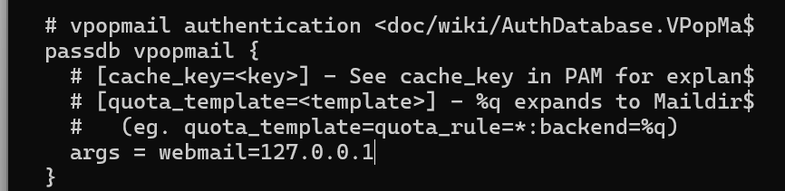

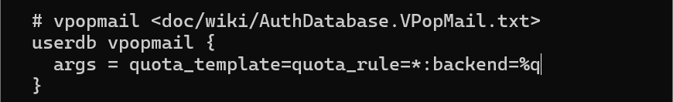

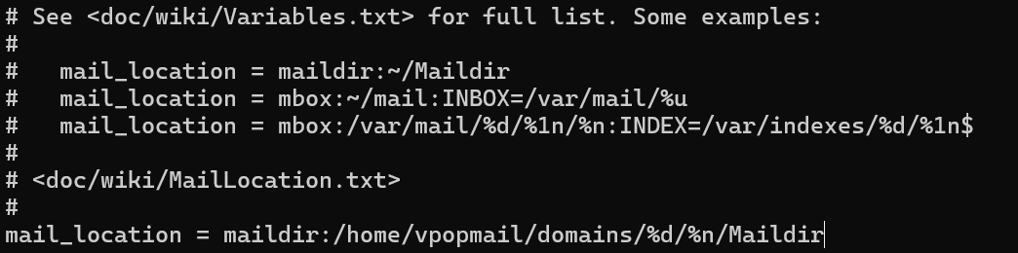

* Create Dovecot startup script vim /etc/init.d/dovecot with following contents:

==========================

#!/bin/bash

# /etc/rc.d/init.d/dovecot

# Starts the dovecot daemon

# chkconfig: – 65 35

# description: Dovecot Imap Server

# processname: dovecot

# Source function library.

. /etc/init.d/functions

test -x /usr/local/sbin/dovecot || exit 0

RETVAL=0

prog="Dovecot Imap"

start() {

echo -n $"Starting $prog: "

daemon /usr/local/sbin/dovecot

RETVAL=$?

[ $RETVAL -eq 0 ] && touch /var/lock/subsys/dovecot

echo

}

stop() {

echo -n $"Stopping $prog: "

killproc /usr/local/sbin/dovecot

RETVAL=$?

[ $RETVAL -eq 0 ] && rm -f /var/lock/subsys/dovecot

echo

}

# See how we were called.

case "$1" in

start)

start

;;

stop)

stop

;;

reload|restart)

stop

start

RETVAL=$?

;;

condrestart)

if [ -f /var/lock/subsys/dovecot ]; then

stop

start

fi

;;

status)

status /usr/local/sbin/dovecot

RETVAL=$?

;;

*)

echo $"Usage: $0 {condrestart|start|stop|restart|reload|status}"

exit 1

esac

exit $RETVAL

==========================

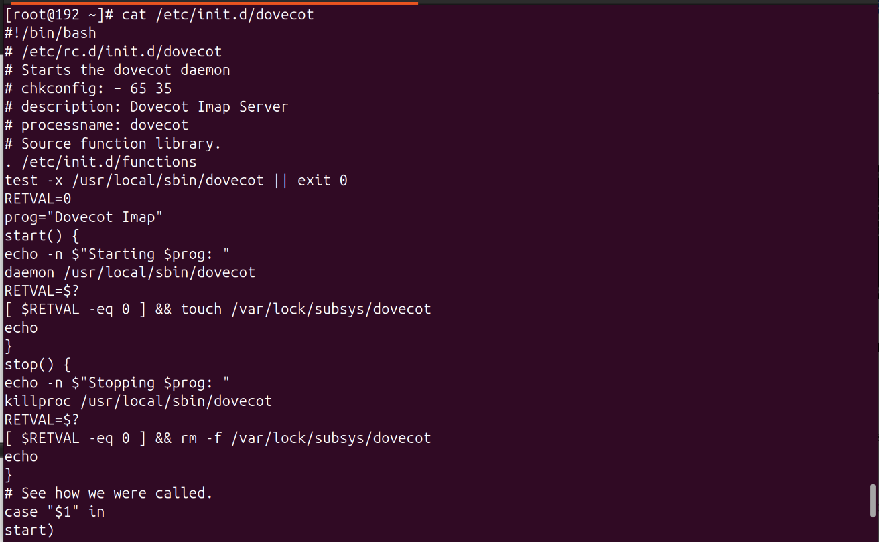

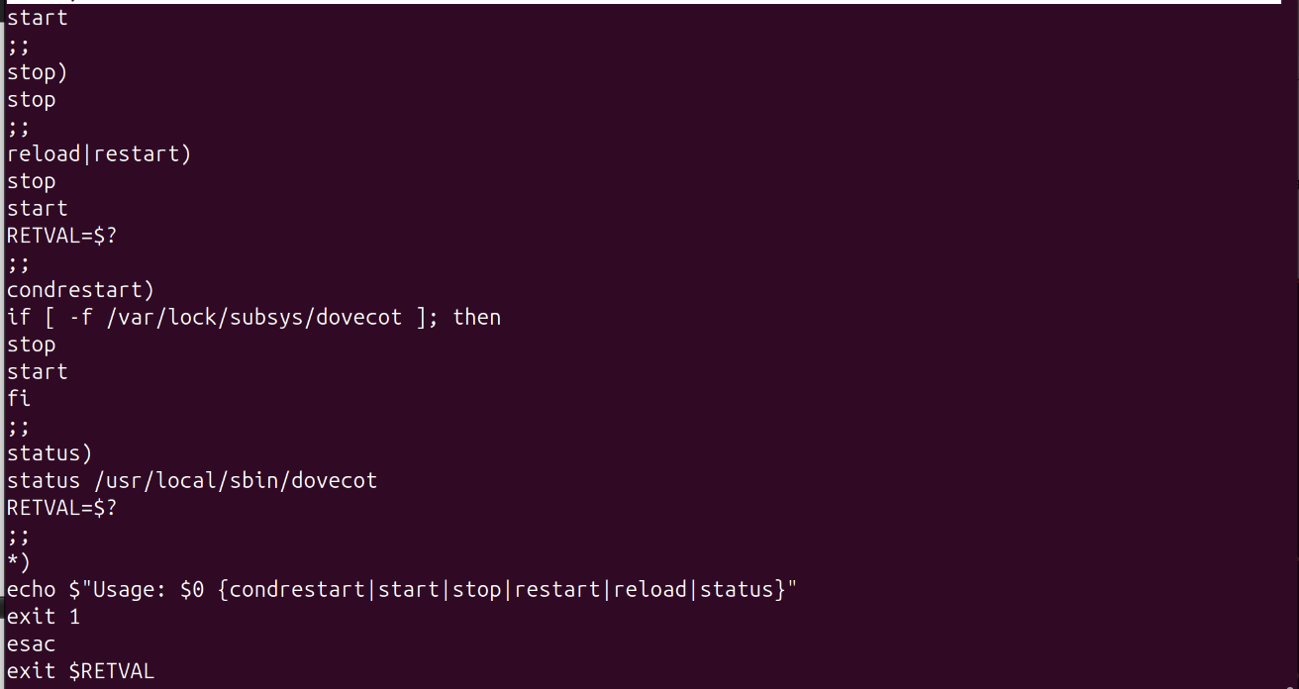

* make /etc/init.d/dovecot executable

chmod 755 /etc/init.d/dovecot

* Create dovecot user

useradd dovecot

* Start dovecot

/etc/init.d/dovecot start

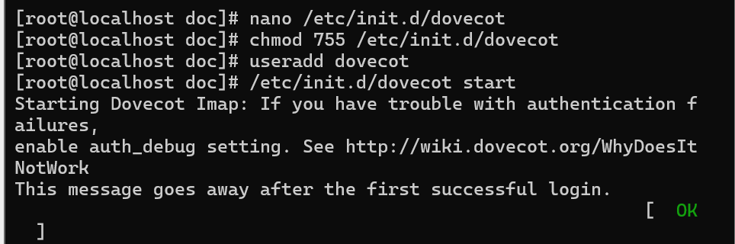

**Configure qmail-smtpd run file**

cd /service/qmail-smtpd

cp -pv run run.bak

vim run

===============================================================

#!/bin/sh

set -x

QMAILDUID=`id -u qmaild`

NOFILESGID=`id -g qmaild`

MAXSMTPD=`cat /var/qmail/control/concurrencyincoming`

LOCAL=`head -1 /var/qmail/control/me`

if [ -z "$QMAILDUID" -o -z "$NOFILESGID" -o -z "$MAXSMTPD" -o -z "$LOCAL" ]; then

echo QMAILDUID, NOFILESGID, MAXSMTPD, or LOCAL is unset in

echo /var/qmail/supervise/qmail-smtpd/run

exit 1

fi

if [ ! -f /var/qmail/control/rcpthosts ]; then

echo "No /var/qmail/control/rcpthosts!"

echo "Refusing to start SMTP listener because it’ll create an open relay"

exit 1

fi

exec /usr/local/bin/softlimit -m 9000000 /usr/local/bin/tcpserver -v -R -l "$LOCAL" -x /etc/tcp.smtp.cdb -c "$MAXSMTPD" -u "$QMAILDUID" -g "$NOFILESGID" 0 smtp /var/qmail/bin/qmail-smtpd 2>&1

===============================================================

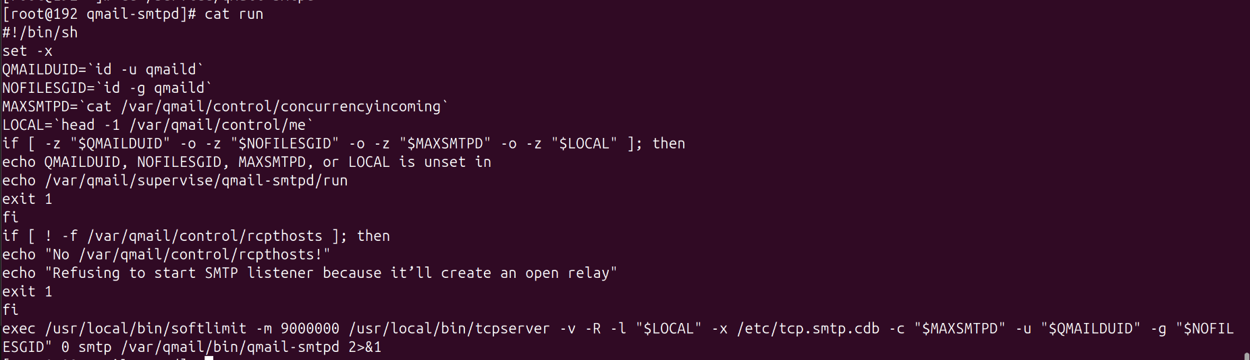

# grep 509 /etc/passwd

vpopmail:x:509:509::/home/vpopmail:/bin/bash

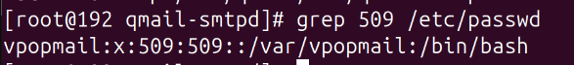

**Connect VPOPMAIL with MySQL**

* update password user **root** at database **mysql**

mysqld_safe --skip-grant-tables &

mysql -u root

**mysql>** USE mysql;

**mysql>** UPDATE user SET password=PASSWORD('kiet') WHERE User='root';

**mysql>** FLUSH PRIVILEGES;

**mysql>** EXIT;

service mysqld stop

service mysqld start

* These commands create the MySQL user **vpopmail_usr**, grant basic and full access on the database **vpopmail_db**, and refresh the access so that vpopmail can use it

mysql -u root -p

**mysql>** CREATE USER 'vpopmail_usr'@'localhost' IDENTIFIED BY 'kiet';

**mysql>** GRANT USAGE ON *.* TO 'vpopmail_usr'@'localhost' IDENTIFIED BY 'kiet';

**mysql>** CREATE DATABASE IF NOT EXISTS `vpopmail_db` ;

**mysql>** GRANT ALL PRIVILEGES ON `vpopmail_db`.* TO 'vpopmail_usr'@'localhost';

**mysql>** FLUSH PRIVILEGES;

**mysql>** SHOW DATABASES;

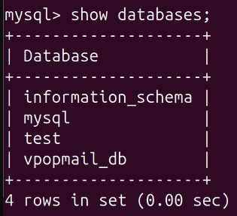

* Compile:

cd /usr/local/src/build/vpopmail-5.4.33

./configure \

--enable-qmaildir=/var/qmail/ \

--enable-qmail-newu=/var/qmail/bin/qmail-newu \

--enable-qmail-inject=/var/qmail/bin/qmail-inject \

--enable-qmail-newmrh=/var/qmail/bin/qmail-newmrh \

--disable-roaming-users \

--enable-auth-module=mysql \

--enable-incdir=/usr/include/mysql \

--enable-libdir=/usr/lib64/mysql \

--enable-logging=p \

--disable-clear-passwd \

--enable-auth-logging \

--enable-sql-logging \

--disable-valias \

--disable-passwd \

--enable-qmail-ext \

--enable-learn-passwords \

--enable-mysql-limits \

--enable-sql-aliasdomains \

--enable-defaultdelivery \

--with-mysql-host=localhost \

--with-mysql-user=vpopmail_usr \

--with-mysql-password=kiet \

--with-mysql-database=vpopmail_db

*Note:*

| **Option** | **Description** |
| --- | --- |
| --enable-qmaildir=/var/qmail/ | Set the root directory for Qmail |
| --enable-qmail-newu=/var/qmail/bin/qmail-newu | Set the path for qmail-newu to manage new users |
| --enable-qmail-inject=/var/qmail/bin/qmail-inject | Set the path for qmail-inject to inject emails into the system |
| --enable-qmail-newmrh=/var/qmail/bin/qmail-newmrh | Set the path for qmail-newmrh to manage new emails |
| --disable-roaming-users | Disable the roaming users feature |
| --enable-auth-module=mysql | Enable authentication via MySQL |
| --enable-incdir=/usr/include/mysql | Set the directory for MySQL header files |
| --enable-libdir=/usr/lib64/mysql | Set the directory for MySQL libraries |
| --enable-logging=p | Enable logging feature |
| --disable-clear-passwd | Disable the use of clear-text passwords |
| --enable-auth-logging | Enable logging of authentication events |
| --enable-sql-logging | Enable SQL query logging |
| --disable-valias | Disable email alias management |
| --disable-passwd | Disable password usage in the system |
| --enable-qmail-ext | Enable Qmail extensions |
| --enable-learn-passwords | Allow Qmail to learn user passwords |
| --enable-mysql-limits | Enable MySQL limits (email count, mailbox size, …) |
| --enable-sql-aliasdomains | Enable alias domains in SQL |
| --enable-defaultdelivery | Enable the default delivery mode |
| --with-mysql-host=localhost | Set the MySQL server to localhost |
| --with-mysql-user=vpopmail_usr | Use the MySQL user vpopmail_usr for connection |
| --with-mysql-password=kiet | Use the password kiet for the MySQL user |
| --with-mysql-database=vpopmail_db | Set the MySQL database to vpopmail_db |

make && make install-strip

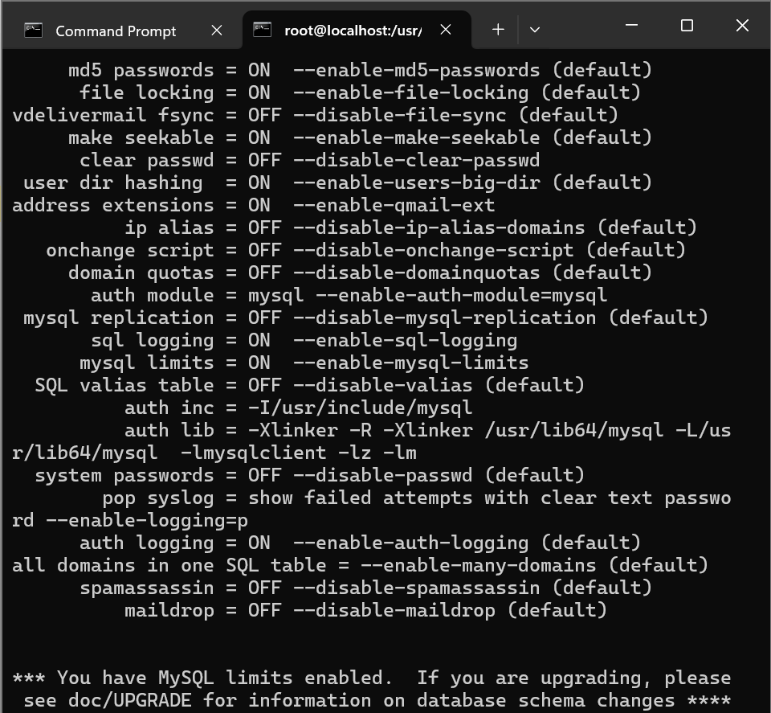

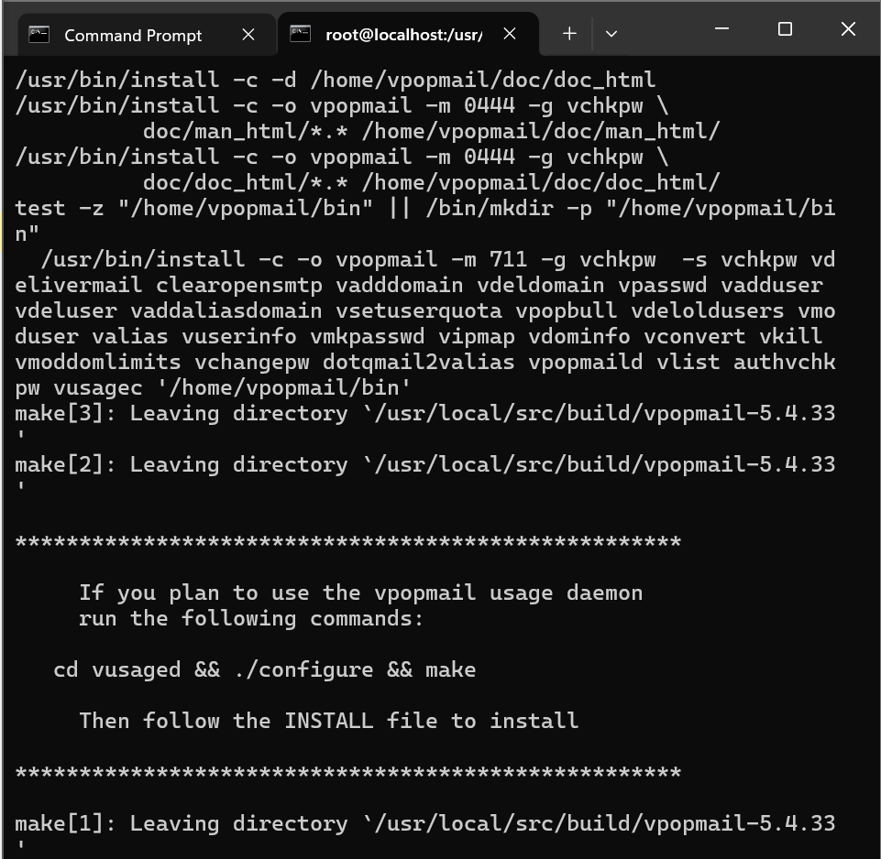

vi /home/vpopmail/etc/vpopmail.mysql

===================================

**localhost|0|vpopmail_usr|kiet|vpopmail_db**

===================================

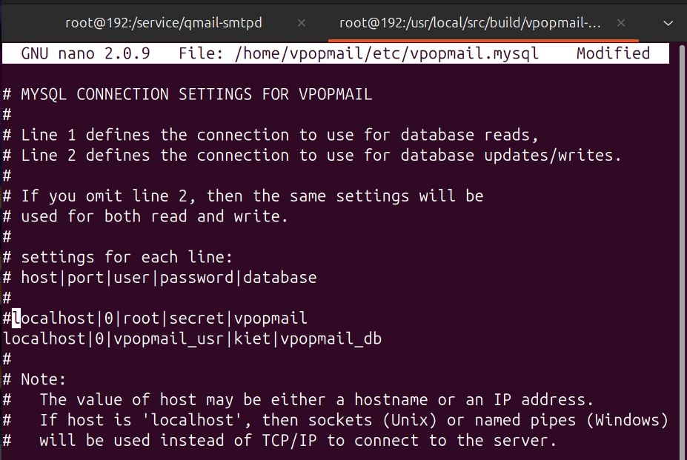

**add users && delete user**

**add domain** **kietdemo.local** and user **testuser**

* add domain **kietdemo.local**:

/home/vpopmail/bin/vadddomain kietdemo.local

(typing pass: kiet)

* add user **testuser (pass:** kiet**):**

/home/vpopmail/bin/vadduser testuser@kietdemo.local kiet

* check user info **testuser** of domain **kietdemo.local**:

/var/vpopmail/bin/vuserinfo testuser@kietdemo.local

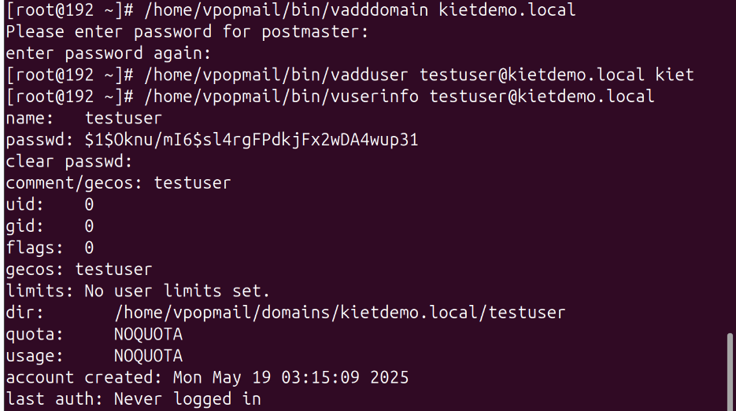

* Check at database:

**mysql>** use vpopmail_db;

**mysql>** show tables; *(auto generated tables, attributes and auto added data)*

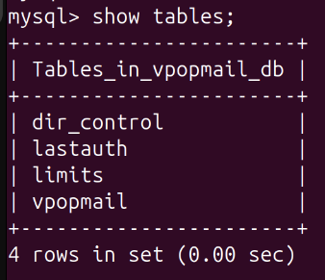

**mysql>** select * from dir_control;

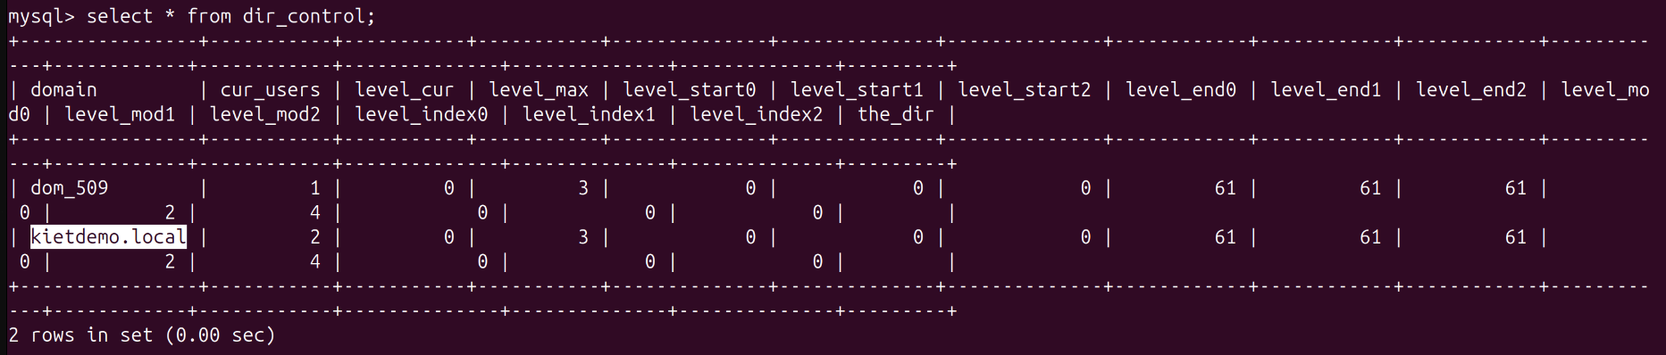

**mysql>** select * from lastauth;

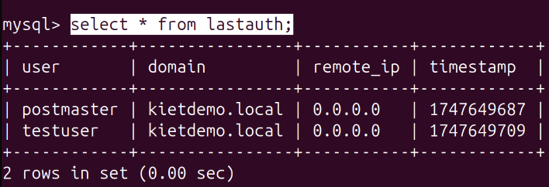

**mysql>** select * from vpopmail;

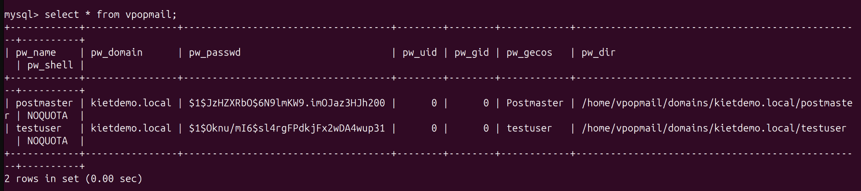

**delete user and check user info ‘testuser’:**

* delete: /var/vpopmail/bin/vdeluser testuser@kietdemo.local
* check: /var/vpopmail/bin/vuserinfo testuser@kietdemo.local

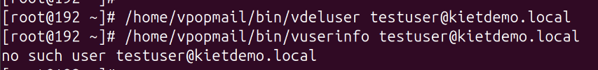

**RECHECK:**

**mysql>** select * from lastauth;

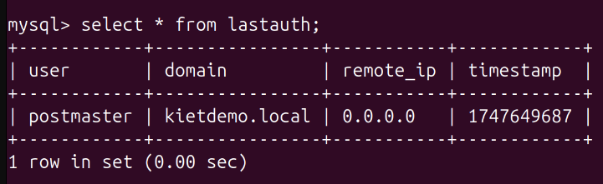

**mysql>** select * from vpopmail;

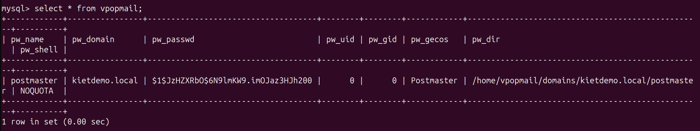

**Send email test with VPOPMAIL and QMAIL**

* Add 2 users **user1 and user2** with domain **kietdemo.local**

/var/vpopmail/bin/vadduser [**user1@kietdemo.local**](mailto:user1@kietdemo.local) kiet

/var/vpopmail/bin/vadduser [**user2@kietdemo.local**](mailto:user2@kietdemo.local) kiet

* check users in database:

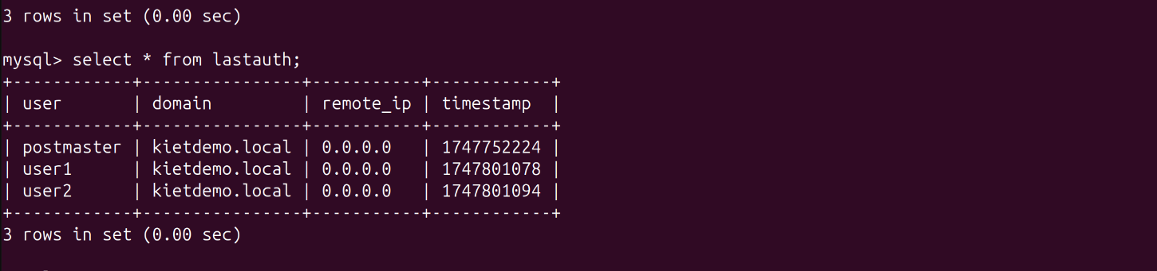

* Test send mail (send mail from **user root** [**root@kietdemo.local**](mailto:root@kietdemo.local)

to **user vpopmail** [**user1@kietdemo.local**](mailto:user1@kietdemo.local))

echo "test" | mail -s "Test again" **user1@kietdemo.local**

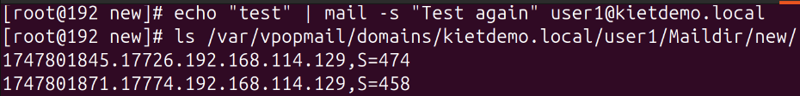

* check mail at **/var/vpopmail/domains/kietdemo.local/user1/Maildir/new/\***:

cat **/var/vpopmail/domains/kietdemo.local/user1/Maildir/new/**1747801871.17774.192.168.114.129,S=458

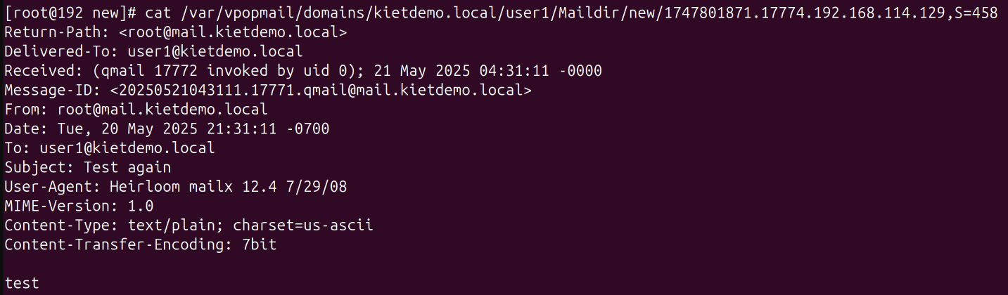

* test send mail (send mail from [**user1@kietdemo.local**](mailto:user1@kietdemo.local)

to [**user2@kietdemo.local**](mailto:user2@kietdemo.local)), those users belong to the domain **kietdemo.local**, use telnet with port 25:

telnet localhost 25

HELO localhost

MAIL FROM:<[**user1@kietdemo.local**](mailto:user1@kietdemo.local)>

RCPT TO:<[**user2@kietdemo.local**](mailto:user2@kietdemo.local)>

DATA

Subject: Test from telnet

This is a test mail send via telnet

.

QUIT

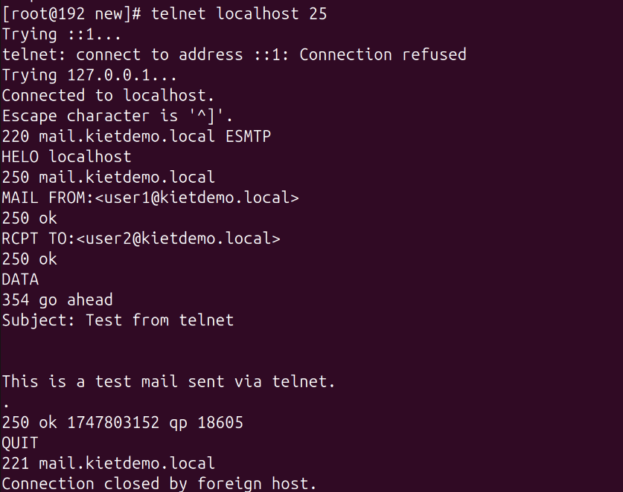

* check mail at **/var/vpopmail/domains/kietdemo.local/user2/Maildir/new/**:

